Name: | ___________________________________________________ |  |  |  |  | Date: ___________
 | Subject - Year 8 Mathematics  Investigation 1, 2018  Topic – Perimeter & Area  In class component |  |  |  |  | 38  = %
Total Time: | 60 minutes
Equipment: | Scientific Calculator, Take home component
AIM: In this assessment, you will be investigating area and perimeter for simple and composite shapes.

- Miranda’s bedroom is 5m by 4m, with a door way that is 1m wide in one of the 4m sides. This is the floor plan.
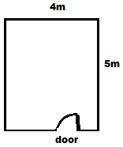
- Calculate the perimeter of the room?

- To protect the walls people install skirting boards around the base of the walls. What length of skirting board will Miranda need to buy to go around the edge of her room? (there is no skirting board where the door is)

- Area of rectangular carpet
Miranda decided to put a rectangular carpet in her bedroom.

- What is the maximum length and width of carpet she should use?

Length: ______ Width:_______

- What is the area of this carpet?

- Perimeter and Area of a Square
Miranda decides to use a square mat.

- What is the maximum length of the largest square mat that could fit in her room?

- Miranda wishes to add protection around the perimeter of the carpet. What length of protection material will she need? (Find the perimeter of the carpet)

- What is the area of the carpet?

- Area of a triangle
Miranda wants a shade sail as shown below

- Calculate the area of material needed to make this shade sail

- Miranda decides to use a design like this one below

Calculate the area of material used?

- Area of a rectangle with a rectangle removed
Miranda decides put grass in the back yard which is 15m x 12m and includes a fish pond in the centre measuring 2.4m x 2m.

- Draw a diagram of the back yard.

- Mark all the measurements on the diagram

- What is the area of the yard

- What is the area of the fish pond

- What is the area of grass needed?

- Volume of a prism
Miranda decides that she will install a swimming pool instead of a fish pond.

The pool she wants to install has a trapezium shaped cross-section.

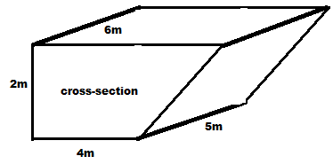

- What is the area of the cross-section?

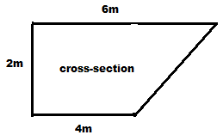

- If the pool is 5m long what is the volume of the pool?

- How many litres of water would it take to fill the pool up to the top?

- Tiled rectangles
Miranda has a very small kitchen 2m by 3m and wishes to tile the floor with square tiles that have a length of 200mm.

- What is the area of each tile?

    - In $mm^{2}$

    - In $m^{2}$

- How many tiles are needed along the longest wall?

- How many tiles are needed along the shortest wall?

- How many tiles are needed all together?

- What is the total area of the tiled floor?

